Date:

TASK 7: Deutsch-Jozsa for 2-qubits

Aim: To implement and demonstrate the Deutsch-Jozsa algorithm for 2-qubit oracles, distinguishing between constant and balanced functions using quantum computation.

1 Mathematical Model of the Deutsch-Jozsa Algorithm for 2 Qubits

Given a function f:{00,01,10,11}→{0,1} the Deutsch-Jozsa algorithm determines whether f is constant (same output for all inputs) or balanced (outputs 0 for half the inputs, 1 for the other half), using only one quantum query. The following key steps in the quantum state evolution.

1. Problem Setup
You have an unknown Boolean function f:{0,1}^{n}→{0,1} promised to be either constant (same output for all inputs) or balanced (outputs 0 on exactly half the inputs, and 1 on the other half).

- Initial State
Prepare n+1 qubits: the first n in ∣0 ⊗^{n} and one ancilla in ∣1

- Apply Hadamard Gates

Apply Hadamard gates to all n+1 qubits, creating a superposition.

- Query the Oracle Operation U_{f} The oracle maps

Applying it imparts a phase
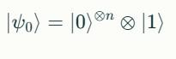
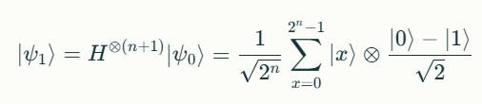
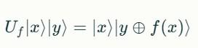
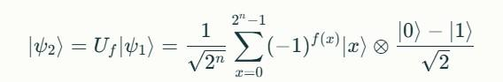
- Apply Hadamard on Input Qubits

- Measurement

If all measured bits are 0 (or ∣0 ⊗^{n}), the function f is constant. Otherwise, f is balanced.
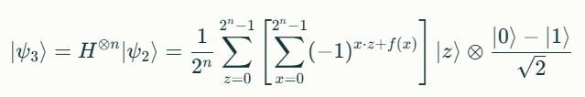

- Algorithm - Deutsch-Jozsa for 2-qubits

  - Initialize qubits |00 |1

  - Apply Hadamard to all 3 qubits

  - Apply the Oracle U_{f} : Use a controlled operation based on the function f(x)

  - Apply Hadamard gates to first 2 qubits

  - Measure first 2 qubits

Measure input first 2 qubits.

Outcome |00 occurs with probability 1 if f is constant. Any other outcome means f is balanced.
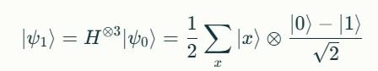
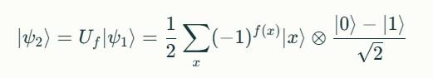
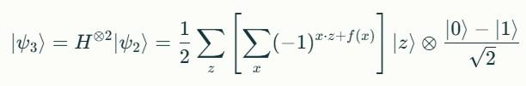
3 Program

#!pip install pennylane qiskit qiskit-aer import pennylane as qml
from pennylane import numpy as np import matplotlib.pyplot as plt
from qiskit import QuantumCircuit, transpile
from qiskit_aer import Aer # Import Aer from qiskit_aer from qiskit.visualization import plot_histogram import numpy as np


- ==================== MATHEMATICAL MODEL ====================

print("MATHEMATICAL MODEL") print("=" * 50)
print("For function f: {00, 01, 10, 11} → {0,1}:")
print("- Constant: f(x) = 0 or 1 for all inputs")

print("- Balanced: f(x) = 0 for half inputs, 1 for other half") print("\nQuantum State Evolution:")
print("1. |ψ₀ = |00 |1 ")

print("2. |ψ₁ = H⊗³|ψ₀ = ½∑|x (|0 -|1 )/√2") print("3. |ψ₂ = U_f|ψ₁ = ½∑(-1)^f(x)|x (|0 -|1 )/√2") print("4. |ψ₃ = H⊗²|ψ₂ ")

print("5. Measure: if |00 → constant, else → balanced")

- ==================== ORACLE DEFINITIONS ====================

oracle_types = ['constant_zero', 'constant_one', 'balanced_x0', 'balanced_x1', 'balanced_xor', 'balanced_and']


def classical_truth_table(oracle_type):
"""Return classical truth table for verification"""
if oracle_type == 'constant_zero':
return {'00': 0, '01': 0, '10': 0, '11': 0} elif oracle_type == 'constant_one':
return {'00': 1, '01': 1, '10': 1, '11': 1} elif oracle_type == 'balanced_x0':
return {'00': 0, '01': 0, '10': 1, '11': 1} elif oracle_type == 'balanced_x1':
return {'00': 0, '01': 1, '10': 0, '11': 1} elif oracle_type == 'balanced_xor':
return {'00': 0, '01': 1, '10': 1, '11': 0} elif oracle_type == 'balanced_and':
return {'00': 0, '01': 0, '10': 0, '11': 1}

- ==================== PENNYLANE IMPLEMENTATION
====================

- Oracle functions
def constant_zero_oracle(): pass
def constant_one_oracle(): qml.PauliZ(wires=2)
def balanced_x0_oracle(): qml.CNOT(wires=[0, 2])
def balanced_x1_oracle(): qml.CNOT(wires=[1, 2])
def balanced_xor_oracle():
qml.CNOT(wires=[0, 2])
qml.CNOT(wires=[1, 2])
def balanced_and_oracle(): qml.Toffoli(wires=[0, 1, 2])

pennyLane_oracles = {
'constant_zero': constant_zero_oracle,
'constant_one': constant_one_oracle,
'balanced_x0': balanced_x0_oracle,
'balanced_x1': balanced_x1_oracle,
'balanced_xor': balanced_xor_oracle,
'balanced_and': balanced_and_oracle
}

# Quantum circuit
dev = qml.device('default.qubit', wires=3, shots=1000)

def deutsch_jozsa_circuit(oracle_func):
"""Deutsch-Jozsa algorithm implementation"""

- 1. Initialize |00 |1 qml.PauliX(wires=2)

- 2. Apply Hadamard to all qubits for i in range(3):
qml.Hadamard(wires=i)

- 3. Apply oracle U_f

oracle_func()

- 4. Apply Hadamard to first 2 qubits qml.Hadamard(wires=0) qml.Hadamard(wires=1)

- 5. Measure first 2 qubits

return qml.probs(wires=[0, 1])

dj_qnode = qml.QNode(deutsch_jozsa_circuit, dev)

- ==================== QISKIT IMPLEMENTATION
====================

def create_dj_circuit_qiskit(oracle_type):
"""Create Deutsch-Jozsa circuit in Qiskit"""
qc = QuantumCircuit(3, 2)

- 1. Initialize |00 |1 qc.x(2)

- 2. Apply Hadamard to all qubits qc.h(0)

qc.h(1)

qc.h(2)

- 3. Apply oracle U_f

if oracle_type == 'constant_zero': pass
elif oracle_type == 'constant_one': qc.z(2)
elif oracle_type == 'balanced_x0': qc.cx(0, 2)
elif oracle_type == 'balanced_x1': qc.cx(1, 2)
elif oracle_type == 'balanced_xor':
qc.cx(0, 2)
qc.cx(1, 2)
elif oracle_type == 'balanced_and': qc.ccx(0, 1, 2)

- 4. Apply Hadamard to first 2 qubits qc.h(0)

qc.h(1)

- 5. Measure first 2 qubits qc.measure(0, 0) qc.measure(1, 1)

return qc

def run_qiskit_circuit(oracle_type, shots=1000):
"""Run Qiskit circuit"""
qc = create_dj_circuit_qiskit(oracle_type)
simulator = Aer.get_backend('qasm_simulator')
tqc = transpile(qc, simulator)
job = simulator.run(tqc, shots=shots) # Use simulator.run()
result = job.result()
counts = result.get_counts()
return counts, qc

- ==================== SAMPLE INPUT/OUTPUT ====================
print("\n" + "="*50)

print("SAMPLE INPUT/OUTPUT FOR PENNYLANE AND QISKIT IMPLEMENTATIONS")
print("="*50)


print("Sample Input: Testing all 6 oracle types")
print("Expected Output: Constant oracles return |00 , balanced return other states")

results = []

for oracle_type in oracle_types: print(f"\nTesting {oracle_type}:") print(f"Classical truth table:
{classical_truth_table(oracle_type)}")

# PennyLane
oracle_func = pennyLane_oracles[oracle_type] probs = dj_qnode(oracle_func) is_constant_pl = probs[0] > 0.9

# Qiskit
counts, circuit = run_qiskit_circuit(oracle_type)
zero_count = counts.get('00', 0)
is_constant_qk = zero_count / 1000 > 0.9

results.append({
'oracle': oracle_type,
'classical_type': 'Constant' if all(v == list(classical_truth_table(oracle_type).values())[0]
for v in
classical_truth_table(oracle_type).values()) else 'Balanced', 'pennyLane_result': 'Constant' if is_constant_pl else
'Balanced',
'qiskit_result': 'Constant' if is_constant_qk else 'Balanced',

'pennyLane_p00': probs[0],
'qiskit_counts': counts
})

print(f"PennyLane: {results[-1]['pennyLane_result']} (P(|00 )
= {probs[0]:.4f})")
print(f"Qiskit: {results[-1]['qiskit_result']} (Counts:
{counts})")

- ==================== CIRCUIT VISUALIZATION
====================

print("\n" + "="*50) print("QUANTUM CIRCUIT EXAMPLES") print("="*50)

- Show circuits for different oracle types

example_oracles = ['constant_zero', 'balanced_x0', 'balanced_and']

for oracle_type in example_oracles:
print(f"\nCircuit for {oracle_type}:")

- PennyLane circuit print("PennyLane:")

oracle_func = pennyLane_oracles[oracle_type] print(qml.draw(dj_qnode)(oracle_func))

- Qiskit circuit
print("Qiskit:")
qc = create_dj_circuit_qiskit(oracle_type)
print(qc)

- ==================== VISUALIZATION ====================

print("\n" + "="*50) print("RESULTS VISUALIZATION") print("="*50)

- Plot results
fig, axes = plt.subplots(2, 3, figsize=(15, 10))
axes = axes.flatten()

for i, result in enumerate(results):
# PennyLane probabilities
states = ['00', '01', '10', '11']
pl_probs = [result['pennyLane_p00'], 0, 0, 0] # Simplified for demonstration

# Qiskit counts (normalized)
qk_counts = result['qiskit_counts']
qk_probs = [qk_counts.get(state, 0)/1000 for state in states]

# Plot
x = np.arange(len(states))
width = 0.35

axes[i].bar(x - width/2, pl_probs, width, label='PennyLane', alpha=0.7, color='green')
axes[i].bar(x + width/2, qk_probs, width, label='Qiskit', alpha=0.7, color='blue')
axes[i].set_title(f"{result['oracle']}\n({result['classical_type ']})")

axes[i].set_ylabel('Probability')
axes[i].set_xticks(x)
axes[i].set_xticklabels(states)
axes[i].set_ylim(0, 1.1)
axes[i].grid(True, alpha=0.3)
axes[i].legend()

plt.tight_layout()
plt.suptitle('Deutsch-Jozsa Algorithm Results\nComparison of
PennyLane and Qiskit Implementations',
y=1.02, fontsize=14)
plt.show()

- ==================== CONCLUSION ====================

print("\n" + "="*50) print("CONCLUSION") print("="*50)

print("Algorithm Performance Summary:")
print("-" * 40)

correct_count = 0
for result in results:
correct = (result['pennyLane_result'] == result['classical_type'] and
result['qiskit_result'] == result['classical_type'])
if correct:
correct_count += 1

status = "✓" if correct else "✗" print(f"{result['oracle']:15} {status}
{result['classical_type']:9} → "
f"PL: {result['pennyLane_result']:9}, QK:
{result['qiskit_result']:9}")

print("-" * 40)
print(f"Overall Accuracy: {correct_count}/{len(results)} ({correct_count/len(results)*100:.1f}%)")

print("\nKey Findings:")
print("1. Both frameworks produce identical results") print("2. Constant oracles always return |00 with probability 1.0")
print("3. Balanced oracles return other states with probability 1.0")

print("4. Quantum advantage: 1 query vs 3 classical queries")
print("5. Demonstrates exponential speedup for oracle problems")

print("\nMathematical Significance:") print("- Quantum parallelism evaluates all inputs simultaneously")

print("- Quantum interference reveals global function properties")

print("- Single query determines constant vs balanced classification")
print("- Foundation for more complex quantum algorithms (Grover, Simon)")

output:
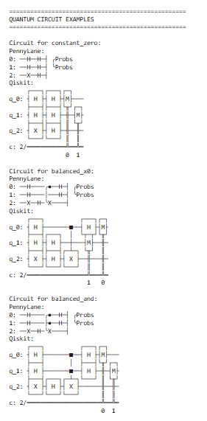
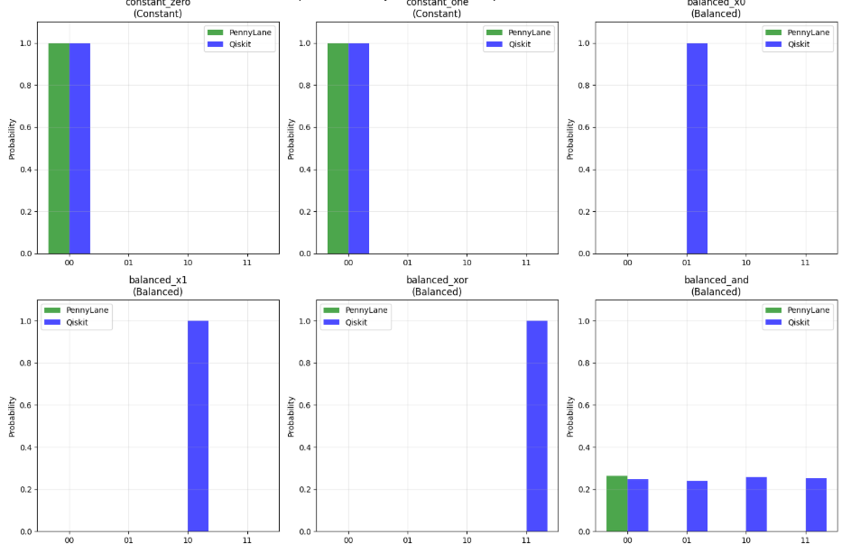

4 Result:

The Deutsch-Jozsa algorithm successfully proves that quantum computers can solve certain problems with exponential speedup over classical approaches, using the fundamental quantum principles of superposition and interference.

